# **Database Tables**

## **Customer Table**

The customer table represents information relating to a user who has registered to make anaccount. The fields in Figure 1 represent the information that captures a customer, which gets encapsulated into three separate objects, Address, Account and Customer.

Figure 1: Structure of Customer Table

Figure 2: Sample Data of Customer Table

[1]

## **Product Table**

The product table contains fields which uniquely describe a product, which as of the current release, may have two categories: Plant and Accessory.

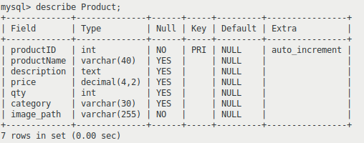

Figure 4: Sample Data for Product table

Figure 3: Structure of Product table

[2]

## **Orders**

The orders table captures data relating to each order a customer has made. A record gets added to this table once the user successfully completes the checkout process. A key area for future development is to simplify the many-to-many relationship that exists between the Orders and Product table.

Figure 5: Structure of Orders Table

Figure 6: Sample Data for Orders Table

1. Note, password field has been cropped for readability reasons, as the hashed password stretches the screenshot aspect ratio out, making text too small
2. Note, the description for productID: 23 is intentionally long-winded to demonstrate usage of JTextArea elements.